**NETFLIX DATA ANALYSIS**

**Executive Summary**

The objective of the study is that the how the film industry pattern changed over the years, which type of movies and tv shows users want to prefer, and which countries and directors are producing it. So, in this study, we want to visualize the patterns and intuitions from the data set. We have selected the data from the Netflix named ***Netflix Titles*.** In data set, there are 12 variables, we have used appropriate variables in this analysis.

The major findings in our analysis is that the film business, which includes both movies and television series, developed rapidly after the year 2000. It was a rapid ascent, and it continues to accelerate as technology and the internet advance. Further, documentaries, stand up comedies, and dramas shows are become increasingly popular in recent years. Moreover, movies and TV series produced in the USA are often aimed at an adult audience; however, movies and TV series produced in India are classified TV-14, indicating that they are intended for audiences aged 14 and up. So, if a movie or TV series made in the United States is suggested, there's a good possibility it was made for older audiences only. The fascinating thing we notice is that, with the exception of India and Egypt, the top ten film makers in the world primarily target a mature audience. This conclusion is acceptable because the mature population accounts for the largest proportion of the global population.

**Introduction of the Data Set**

Netflix in its complete Netflix, Inc. is an American media streaming and video rental firm started in 1997 by Reed Hastings and Marc Randolph. It also participates in the development of original programming. Netflix is a subscription-based streaming service that allows our users to view TV episodes and movies on any internet-connected device without ads. One of the most crucial aspects in Netflix's success has been the long tail idea. They have continued to gain clients due to their capacity to supply substantially more content than any traditional DVD rental company. Netflix has profited from e-commerce advantages such as lower costs and the growth of the marketplace as a result of being a solely internet-based service. Netflix was watched for 10 billion hours each month in 2015. (Smith, 2015). This demonstrates that, despite a plethora of competitors and other options offering the same or comparable content, it has been successful in the attention economy. As a result of optimising factors including the long tail, the subscription business model, and network effects over time, Netflix has evolved into a successful and attention-getting business in the attention economy.

Here, the purpose of the Netflix data is that, we want to analysis the film industry all over the world such what Netflix users prefer more to watch or what users want to watch movies and Tv shows? So, based on the data, our objective is to analysis the production all over the world. The data set is collected from the Netflix website. We have a data of “Netflix titles”. The total number of observations (or show id is s7787) is 7787. The total number of variables are 12. Apart from that, there are some missing values or null values, but we couldn't fill them in or eliminate them because it would have hampered our analytical process and made our conclusions and interpretations erroneous. For this study, we choose an appropriate analytical tool that is tableau.

Next, the data definitions of the variables. The **show id** is the single identification of each movie and TV show of the Netflix; there are the two **types** of shows that is movie, and tv show. **Title**- name of the movies/TV shows, **directors**- name of the director (who direct manages the creative aspects of the production), **cast**- name of the all-lead people/actors who act in it, **country**- who belongs to which country, **release year-** in which year show or movie release, **rating** of the movie or show, **duration**- time of the movie/show, **listed in** describes that dramas, international movies, etc, **description**- summary information about the movie or the TV show for the idea about the story of the movie of Tv show.

**Data Visualization**

**Figure 1**

The below figure shows the top 10 directors in the overall production they have done. They produce both types (that is movies and TV shows). According to the data, we can say that audience prefers more to watch is RaÃºl Campos, Jan Suter director’s movies and TV shows as the unique identification count is highest among the directors.

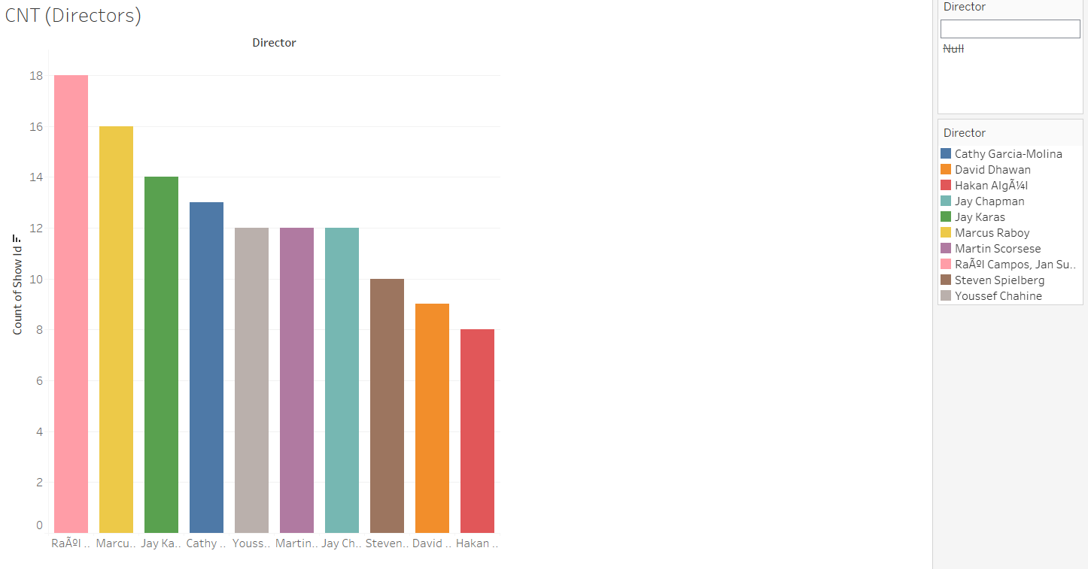

**Figure 2**

In the below graph, we can see that the line of movies and Tv shows start rising gradually after the 2000s. However, after 2010, the sudden boom in the TV shows and movies, maybe the reason behind the boom is that the internet users increase, technology advancement such as smartphones launch at a reasonable price in the market. Hence, the rise in the movies and Tv shows was at its peak till 2019. Thereafter, unfortunately, in the 2020s data shows the reduction in both types of productions because of the covid hit all over the world.

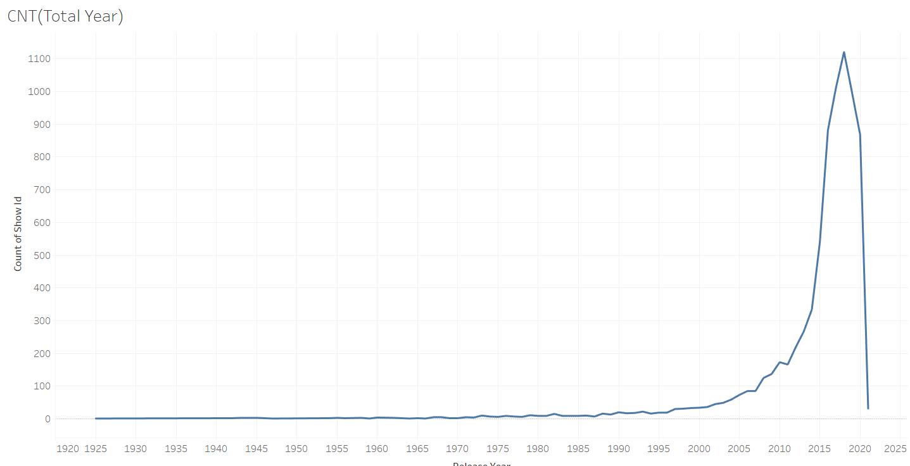

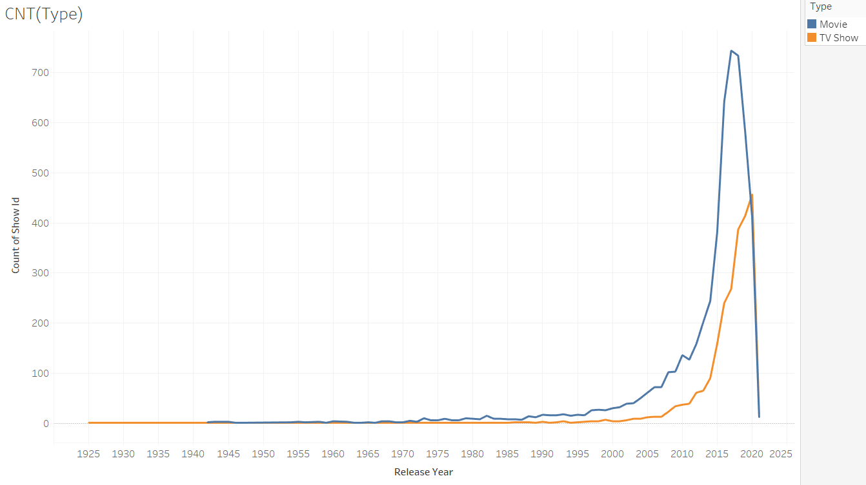

**Figure 3**

In this figure, we can easily observe that the ratings are separated in between the types (i.e., movies and TV shows). As per the graph of movie and ratings, the highest rating for movies is TV-MA which implies that mature audience only. On the other hand, the highest ratings for Tv shows are same as movies i.e., TV-MA. Therefore, audience prefers to watch more content of TV-MA.

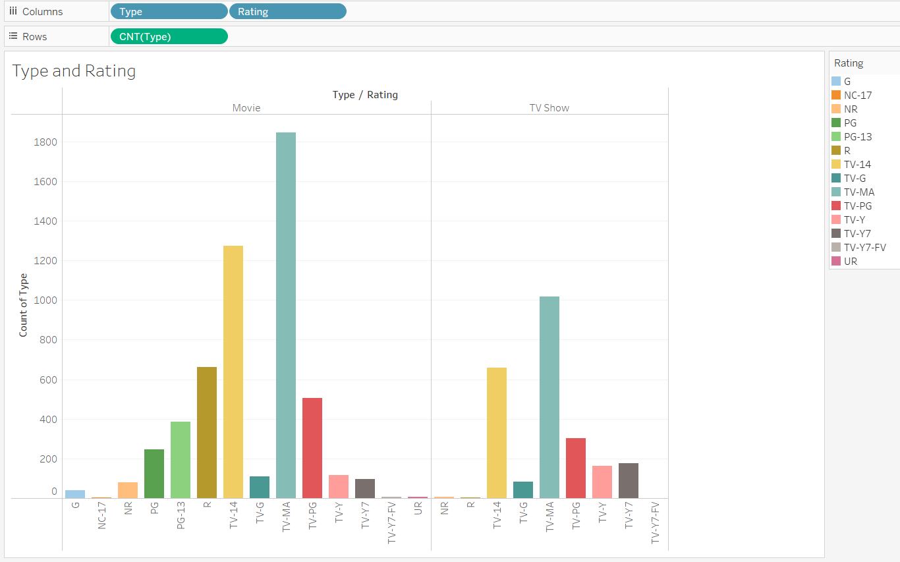

**Figure 4**

In this figure, we can easily observe that the top 10 countries are separated in between the types (i.e., movies and TV shows). As per the graph of movies and countries, the United States of America and India have produced a pointedly high number of movies over the years. Also, the United Kingdom is the 3rd largest who produced a smaller number of movies as compared to India. On the other hand, in the production of TV shows still, the USA is in the highest place but the second-highest production of TV shows in the United Kingdom. Therefore, in the movies and tv shows production USA’s place is highest all the over the years.

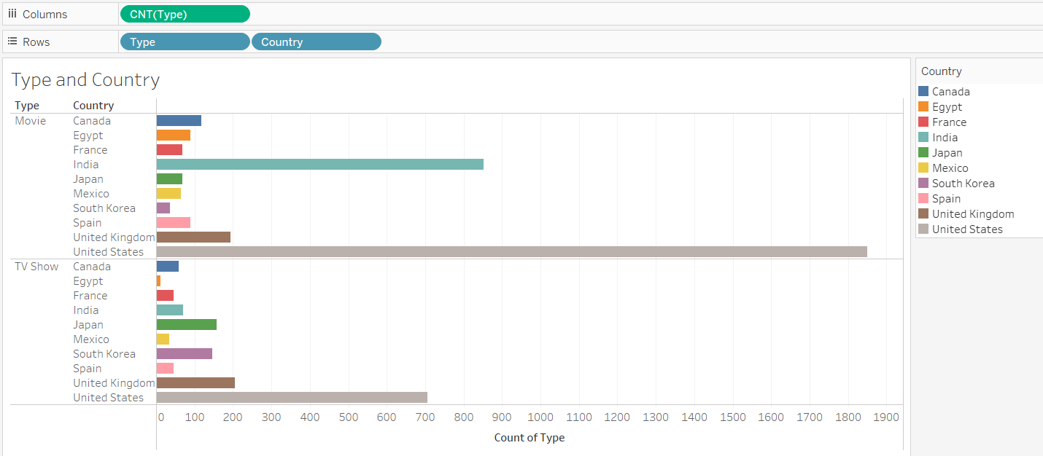

**Figure 5**

The bar graph represents that the total count of movies and tv shows. The total count of movie is approx. more than 5000, whereas, the total count of tv shows is approx. more than 2000. We see that the total movies count is more as compared to TV shows.

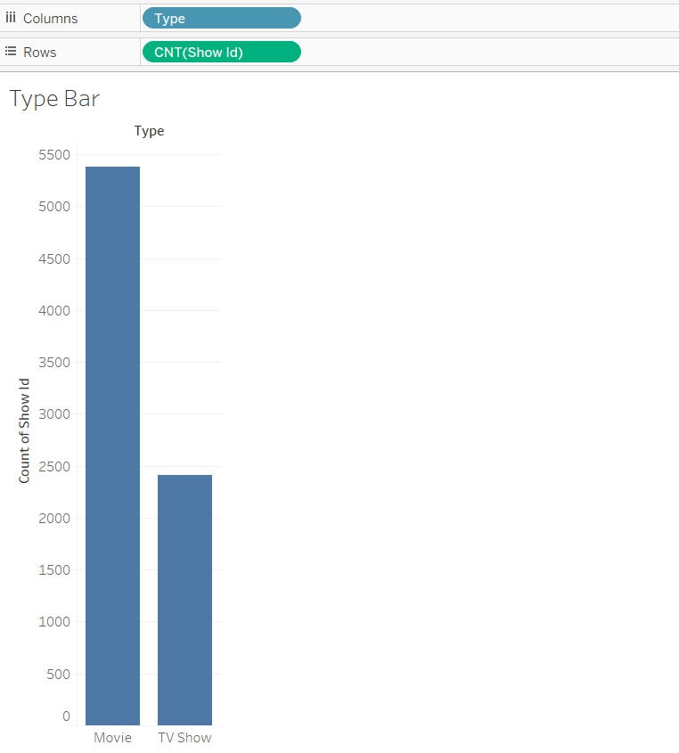

**Figure 6**

We observe in the color map that the USA produced significantly highest number of movies and tv shows. Additionally, India is also in the same line because it also produces more numbers of movies and tv shows. Approximately, USA produces movies and tv shows more than 2500, whereas, India produces movies and tv shows more than 2000.

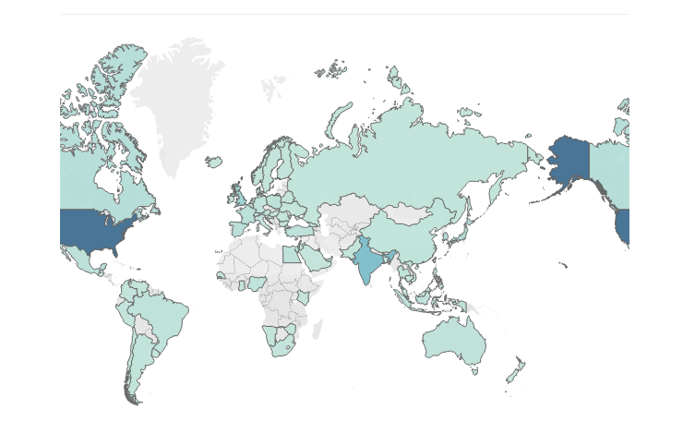

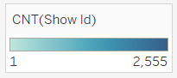

**Figure 7**

Mostly production done for TV-MA ratings (mature or adults’ audience) as compared to other ratings, adults make up the majority of the audience and making this understanding acceptable and comprehensible. On the other hand, the rating of TV-14 (contains very provocative conversation, utterly nonsensical language, violent sex acts, or extreme violence) is the second highest production.

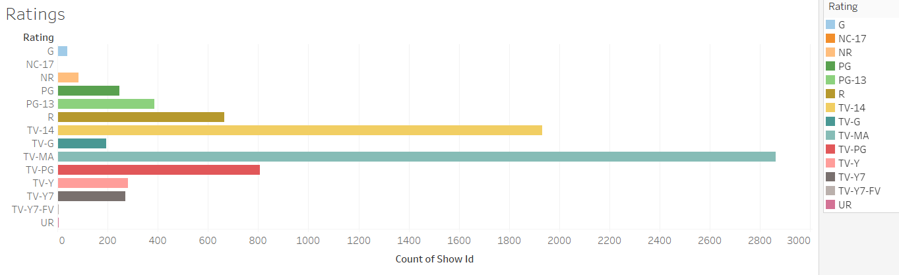

**Figure 8**

There are movies and TV shows where the data shows that the documentaries, stand up comedies, and dramas are the highest among all the listed. These three plays the highest role as compared to other.

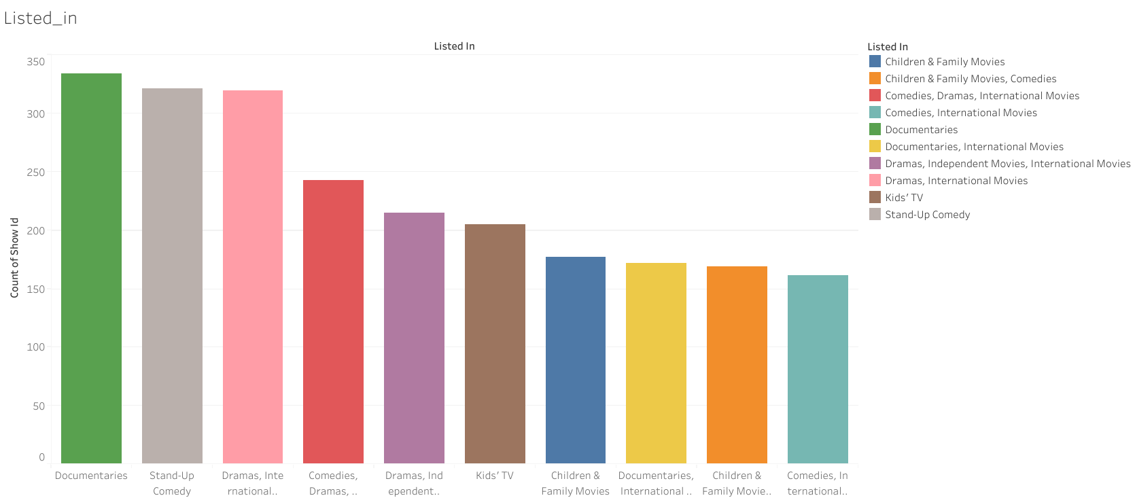

# **References**

Anon., n.d. *Spectrum.* [Online]   
Available at: https://www.spectrum.net/support/tv/tv-and-movie-ratings-descriptions/

Anon., n.d. *Tableau.* [Online]   
Available at: https://help.tableau.com/current/pro/desktop/en-us/examples_pdf.htm